**_№ 1** ___________________________________________________________________

1. Напиши заглавную (Большую) букву рядом со строчной:

i____ ,f____ , r_____ , m______ , b______ , h______ , a_____, d______

1. Соедини слова и картинки:

Fox pig bed sun egg doll cup dog

  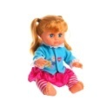  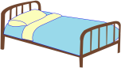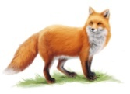

1. Выберете одну строку, где написаны **только** названия животных:

a) pig, cat, dog

b) pig, cat, box

d) pen, cat, dog

1. Вычеркни 1 слово, которое **не обозначает** приветствия:

a) Hello

b) Good-bye

с) Good morning

d) Hi

1. Вставьте гласные буквы: **i**, **о , или e, чтобы получились слова.**
2. b__ x, fr**___**g, f**___**x.
3. m**___**lk, w**___**nd, p**___**g.
4. p**___**n, d**___**sk, t**___**n.
5. **Запиши слова в табличку по .одинаковому чтению (звучанию)**

|  |  |  |  |
| --- | --- | --- | --- |
| bag fish pen lamp doll ship desk pond bed map pig shop | | | |
| **[ I ]** | **[ e ]** | **[ ᴂ ]** | **[ ᴐ ]** |
| **milk** | **ten** | **flag** | **frog** |
|  |  |  |  |
|  |  |  |  |
|  |  |  |  |

1. Что обозначает фраза **«Where are you from»?** Выбери и подчеркни 1 ответ:

a) Как тебя зовут? b) Приятно познакомиться c) Откуда ты?

1. Составь из букв соответствующие слова.
2. pca – ______________ oowd – ______________________
3. hisf – ______________ bkoo – _______________________
4. ohsp – ______________ apml – ________________________
5. Составь из слов предложения:
6. Meggy / see / red / a / can / bag.

______________________________________________________________

1. Green / Bess / see / can / a / lamp.

______________________________________________________________

1. Переведи на английский язык следующие словосочетания:
2. Большой корабль__________________________________________________
3. Черный кот_______________________________________________________
4. Маленький носок__________________________________________________
5. Маленький повар_________________________________________________
6. Зеленое дерево_________________________________________________________

**№ 3**

____________________________________________________________________________

**№ 1. Вставь в предложения am, is , are.**

1. How old ____________________ your sister, Rose?
2. My father and mother _________________________ from Moscow.
3. I _____________________ a good student.
4. They ______________________ cold and sad.
5. ________________________ you twelve?
6. We ______________________ in London.
7. My brother and I ____________________ seven.
8. _______________________ ita cute fox?

**№ 2. Составь из букв числительные, соблюдая правила орфографии.**

***Пример:*** w o t _______two______(2)

1. e e h t r ___________________________(3)
2. o u r f _____________________________(4)
3. v i f e ______________________________(5)
4. n v e e s ___________________________(7)
5. e g h i t ____________________________(8)
6. n l e v e e __________________________(11)
7. w e t v e l __________________________(12)

**№ 3.** Прочитай текст и утверждения после него.

Если утверждение верное, поставь **( +),** если нет – крестик **(-)**.

My mother, father, sister, brother and I are in Paris. It is my father, Sam. He is from Samara. He is not old. He is a pilot. It is my mother, Jane. She is from Novgorod. She is a good and happy mother. My mother is a cook. It is my big brother, Steve. He is a student. He is not a good student. He is funny. It is my sister, Liz. She is five. She is cute.

1. They are in Paris.
2. Sam is not from Novgorod.
3. Sam is a pilot.
4. Jane is a sad mother.
5. Steve is not little.
6. Steve is a bad pupil.
7. Liz is little.

**№ 4**

**______________________________________________________________________**

**№ 1. Вставь в предложения is или are и предлоги (on, under, in, by) в соответствии с картинками.**

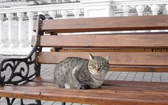 The cat _____ _____ the bench. 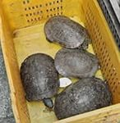 The turtles _____ _____ the box.

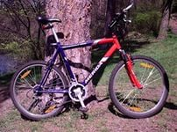 The bike _____ _____ the tree.  The sun _____ _____ the sky.

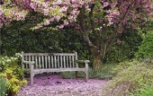 The bench _____ _____ the tree. 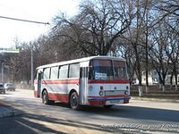 The bus _____ _____ the street.

**№ 2. Напиши множественное число данных существительных.**

a pie - ______________________________ a tulip - ____________________________

a turtle - ____________________________ a dish - ____________________________

a tree - _____________________________ a match - ___________________________

**№ 3. Вставь в текст подходящие слова из рамки.**

|  |
| --- |
| is at and a to pupils are not |

Jane and Dan _________________ a brother and a sister. Jane _______________ twelve.

Tom is ___________twelve. He is ten. Jane is _________ schoolgirl and Dan is a schoolboy. They are good ________________. Jane and Dan are _____________________ school in the afternoon. They like the school. It is big _________________ good. They like ______ play games, run and jump in the park.

**№ 5. Прочитай текст и отметь, какие из фраз после него правильные (+), а какие – нет (-).**

I’m Harry, I’m a troll. I like birches and ferns. I like to sit under the trees in the afternoon. I’m Emily, I’m an elf. I’m eleven. Emma is my sister. She is an elf too. We like bees and ants. We like to play in the woods. We like to swim in the lake too. We like Harry, the troll.

1. Harry is an elf. ( )
2. We can see Harry under a tree in the afternoon. ( )
3. Emily and Emma like cats and dogs. ( )
4. Emily and Emma play in the park. ( )
5. Emily and Emma swim in the lake. ( )